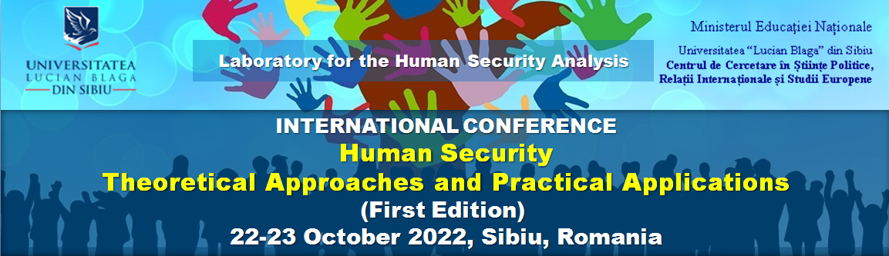

Remarks:  - Please fill in the blue fields only or mark with an X;  - Fill in 1 form for 1 person. If there are 2 or more persons for submitting one article, insert with 1, 2... in the blue fields;  - Send this application form to:  centru.ccsprise@ulbsibiu.ro | I want to participate in
HUMAN SECURITY - THEORETICAL APPROACHES
AND PRACTICAL APPLICATIONS
(FIRST EDITION)
22-23 October, Sibiu, Romania

Male | Female | Rank |  | First name | Last name
 |  | Professor
 |  | Researcher
 |  | Student
 |  | MA student
 |  | PhD student

Date of birth | Nationality

University/Institution

Phone number (if available) | E-mail address

Paper title

Panel
Civil rights and freedoms
Immigrants and refugees in the Eastern Europe
Human security within the Transnistrian issue

Summary (250-300 words in English or Romanian)

Deadline for submitting the Registration form: July 30, 2022

