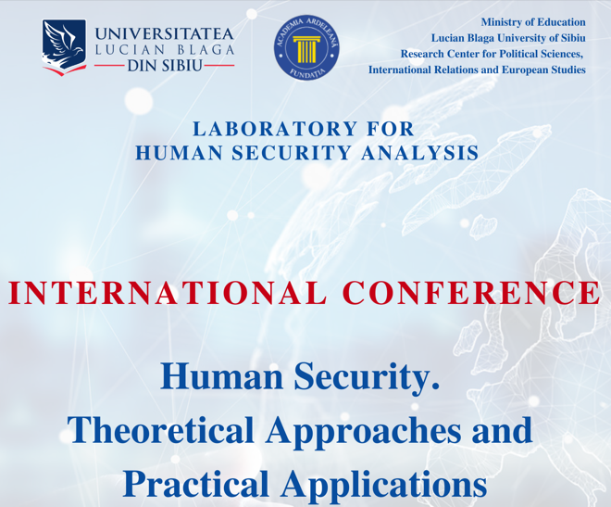
Registration Form
HSTAPA 2023

Remarks:  - Please fill in the blue fields only or mark them with an X;  - Fill in 1 form for 1 person. If there are 2 or more persons submitting one article, insert 1, 2... in the blue fields;  - Send the registration form to:  centru.ccsprise@ulbsibiu.ro | I want to participate in
HUMAN SECURITY. THEORETICAL APPROACHES
AND PRACTICAL APPLICATIONS
(SECOND EDITION)
27th of October 2023, Sibiu, Romania

Male | Female | Rank |  | First name | Last name
 |  | Professor
 |  | Researcher
 |  | Student
 |  | MA student
 |  | Ph.D. student

Date of birth | Nationality

University/Institution

Phone number (if available) | E-mail address

Paper title

Panel
Civil rights and freedoms
Immigrants and refugees in the Eastern Europe
Energy security. Challenges within the current context of international relations
Artificial intelligence, technology and hybrid warfare. Effects on human security

Summary (250-300 words in English)

Deadline for submitting the Registration Form: 30th of July 2023

