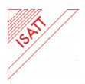
The 19th Biennial Conference of International
Study Association on Teachers and Teaching (ISATT)

"Education beyond the crisis: new skills, children's rights and teaching contexts"

1st - 5th July 2019, Sibiu, Romania
The Lucian Blaga University of Sibiu is inviting you at the 19th Biennial Conference 2019 of International Study Association on Teachers and Teaching

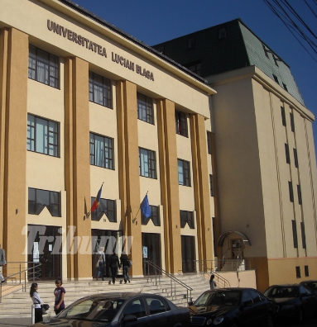
Blvd Victoriei, 550024
Sibiu, Romania
Tel/Fax: 004 0269 217278
conf.isatt@ulbsibiu.ro
http://conferences.ulbsibiu.ro/isatt/
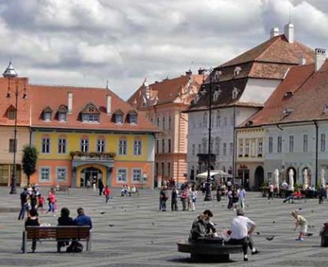

BOOKING FORM

Hotel name
Check in date
Check out date
Nights
Room type
Persons (1/single, 1-2/double or twin/ 3-4 family suite)
Name/surname
Contact: e-mail address/tel.

Invoice details
For payments made by a Company, University, Institute
Please provide the following info:
Full name
Full address
Telephone number
VAT Number
For payments made individually
Please provide the following info:
Full name
Full address
Telephone number
ID number

Payment method
Please mark “X” for your chosen option.

Banking transfer
CC online, following a secured link

Thank you.
Looking forward to meeting you in Sibiu!

